Rename the file to this format: M6-Lab04-yourname.docx or pdf
Class & Module | SAH  Lab04: Recommenders and Clustering/ Assignment4
Name | Goh Rui Kun
IC No. [S****123X] | S****836J
Date & Time | 20th Feb 2021

Create screenshot following the instruction below:
Step 1 of 2
- Following lab instruction, Upload the CSV (ratings.csv and movies.csv) either using Azure Storage Explorer or Azure portal to Azure storage BLOB container in the folder named “data”
- then upload the python notebook: Python Recommender.ipynb
- complete to run the steps in the jupyter notebook

create - paste the screenshot on the partial result of #Test the Recommender in the las cell (10 lines of output rows)
*** place here the screenshot of your data folder ***


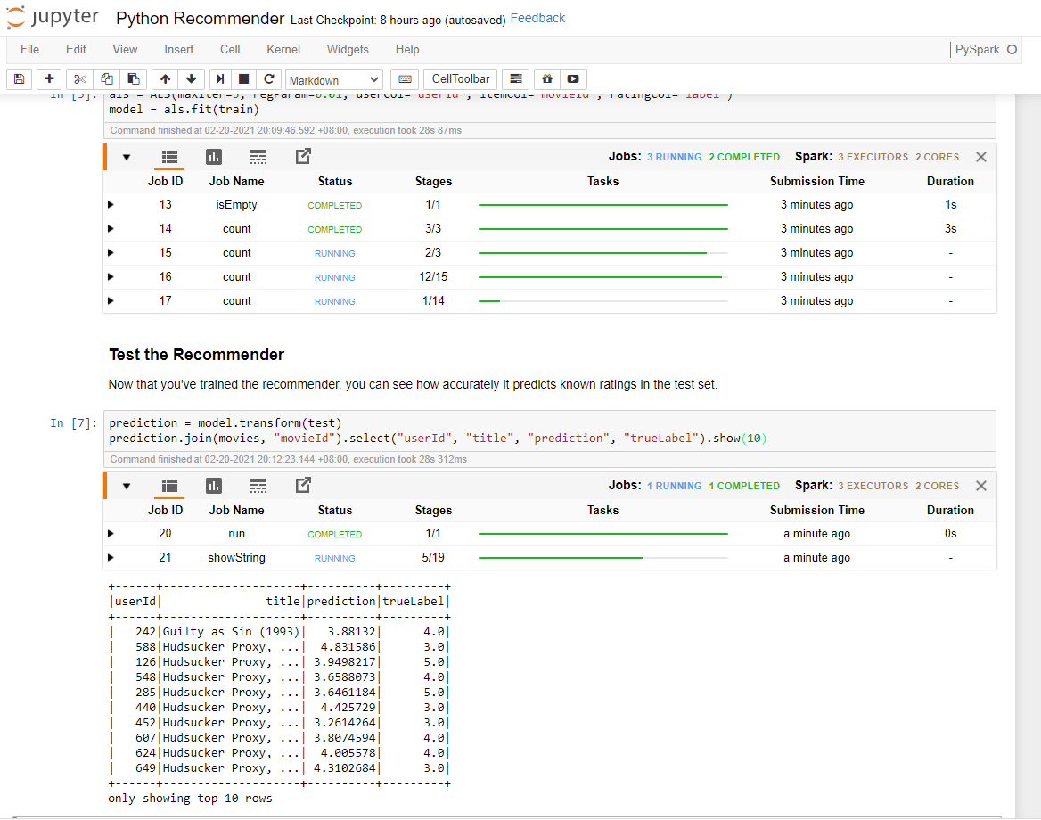

Step 2 of 2
- Following lab instruction, Upload the CSV (customers.csv) either using Azure Storage Explorer or Azure portal to Azure storage BLOB container in the folder named “data”
- then upload the python notebook: Python Clustering.ipynb
- complete to run the steps in the jupyter notebook

create - paste the screenshot on the result of Predict cluster showing cluster number and number of customers in that cluster
*** place here the screenshot of your data folder ***
